**Content Authoring Guide Template**

**User Manual**

# Overview

Once the Sitecore components are developed & deployed for a project, developers will usually prepare a Word/PDF document for the content author, which has instructions on how to use the CMS, add content to a data source, etc.

This *Content Authoring Guide Template* Sitecore module will create a simple & appealing web page template in your Sitecore instance, which serves the same purpose as the former, but with an interesting and user-friendly interface.

The content for this Content Authoring Guide (CAG) page will be picked up from the related Sitecore items.   
All that needs to be done by the developer is to fill the instructions in the respective items.  
  
How is this better than a Word document?  
Hmmm…good question. All I can say is,  
  
These instructions are displayed in an engaging webpage than an otherwise monotonous document.  
The content is rendered from Sitecore items. So it is easy for the developers to create/edit them as and when there is a change.  
This page can be browsed right from the CMS itself instead of having a separate document to refer to all the time.  
As the content is from Sitecore items, the articles will have a consistent format on the page and with the carousel slide, I believe the information would be compelling comparatively.  
Hey… and authors can also use the nice Search feature.

Did I make it convincing enough!!! ☺

The CAG page can be opened from the Launch pad and looks like this: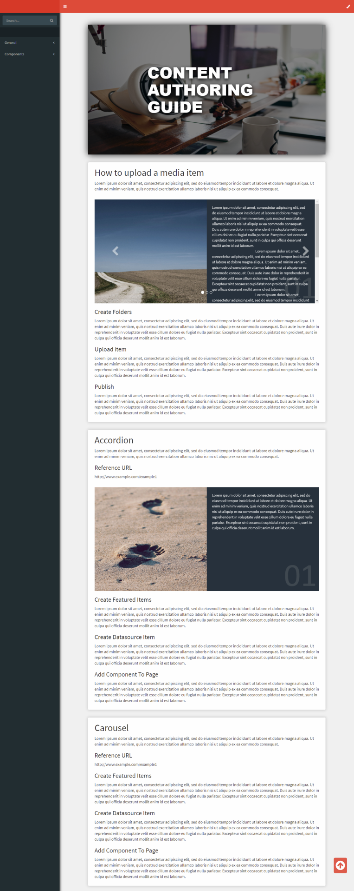

# Package Contents

Installing the package will deploy the following, in your instance:

**TEMPLATES:**   
  
1. /sitecore/templates/Basiscore/Feature/Content Authoring Documentation/  
Documentation Root  
2. /sitecore/templates/Basiscore/Feature/Content Authoring Documentation/Articles Folder  
3. /sitecore/templates/Basiscore/Feature/Content Authoring Documentation/Article  
4. /sitecore/templates/Basiscore/Feature/Content Authoring Documentation/Carousel Slide  
5. /sitecore/templates/Branches/Basiscore/Content Authoring Documentation/  
Documentation Root

**MEDIA:**

/sitecore/media library/Basiscore/Content-Authoring-Guide/...

**SAMPLE CONTENT:**

/sitecore/content/Content Authoring Guide/…

**LAUNCH PAD BUTTON (core database):**

/sitecore/client/Applications/Launchpad/PageSettings/Buttons/Basiscore/Content Authoring Guide

**FILES:**

1. \Website\bin\Basiscore.Feature.ContentAuthoringGuide.dll  
2. \Website\Areas\ContentAuthoringGuide\...  
3. \Website\App_Config\Include\Basiscore\Feature\CAGuide\  
Basiscore.Foundation.CAGuide.config  
  
How to Browse the Guide Page  
  
1. This tool uses MVC Areas in the backend, which has to be registered. So, after installing the package, do an IIS reset from the Internet Information Services (IIS) Manager. This will be a one-time step.  
2. Open the Launch Pad in your instance and click on the **Content Authoring Guide** icon.   
  
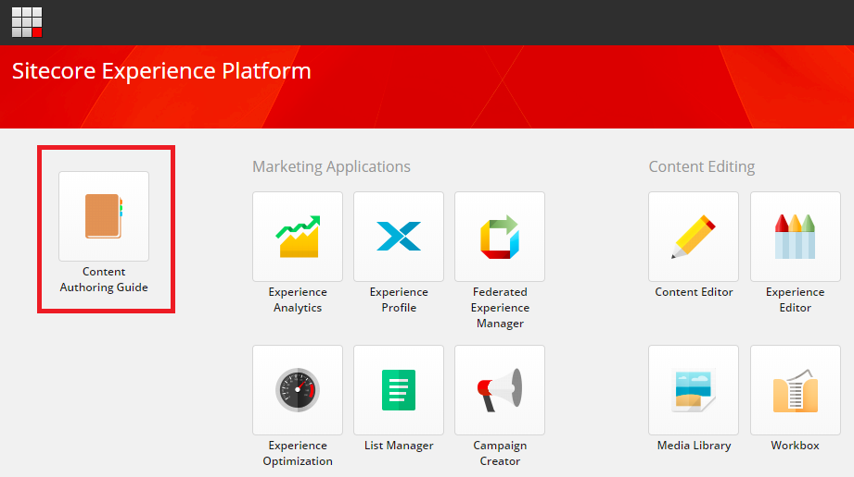  
  
This will open a page with the URL -   
*<instance-name>/ContentAuthoringGuide/{2B2E25EC-1313-42F7-983F-5FDCA163A5CD}*The ID in the URL is the Item ID of the Guide Root Item - */sitecore/content/Content Authoring Guide*.3. The CAG page usually takes a hard refresh the first time, to display the images. If they still do not show up, publish this media library folder and check again -   
*/sitecore/media library/Basiscore/Content-Authoring-Guide/*

**NOTE:**   
  
For the purpose of demonstration, the package also includes some sample content, which is created at - */sitecore/content/Content Authoring Guide*.  
If you like to have this node at some other location, move it there. Afterwards, update its path in the **Link** field of the launch pad button (core database), here -  
*/sitecore/client/Applications/Launchpad/PageSettings/Buttons/Basiscore/Content Authoring Guide*.  
  
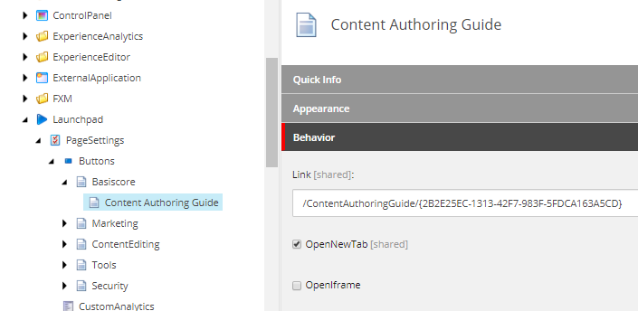The ID here should be the Item ID of the Guide Root Item that you have just created/moved.

How to Add Content for the Guide  
  
Cover Page  


The cover page title, background image and other content can be populated in the respective items in this root item - */sitecore/content/Content Authoring Guide*.

Articles  
  
Let’s assume that you want to impart instructions to the author about two topics:   
How to upload an image in the CMS &  
How to add content for the Accordion component.  
  
It would make sense to categorize these articles. In this case, we can have a *General* category, which will have instructions on all general topics, and then a *Components* category, which will have articles related to components.  
  
1. Under the CAG root item (*/sitecore/content/Content Authoring Guide*), create two **Article Folders** using the template - */sitecore/templates/Basiscore/Feature/Content Authoring Guide/Articles Folder*, and fill in the field values.  
  
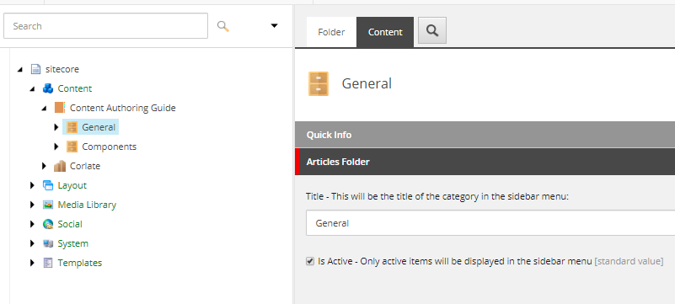  
You can also create **Articles** directly under the CAG root along with **Article Folders**. It all depends on how you would like the sidebar menu to be on the CAG page.  
2. Now create the **Article** under **General** using the template - */sitecore/templates/Basiscore/Feature/Content Authoring Guide/Article*, and fill in the field values.  
  
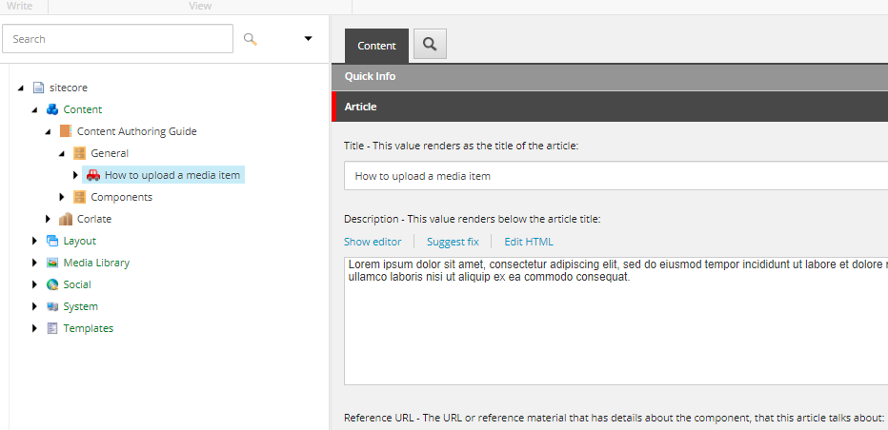  
3. It’s always a good idea to have images in your article that explain your instructions more clearly.  
Upload the related images to Media Library first. Then create a **Carousel Slide** under the **Article** using the template - */sitecore/templates/Basiscore/Feature/Content Authoring Guide/Carousel Slide*, and fill in the field values.  
If you have added content in the *Description* field, it will show the image and the content side-by-side. If there is no content, then the image will be rendered in full width, inside the carousel.  
Add as many such slides as needed for your article.  
  
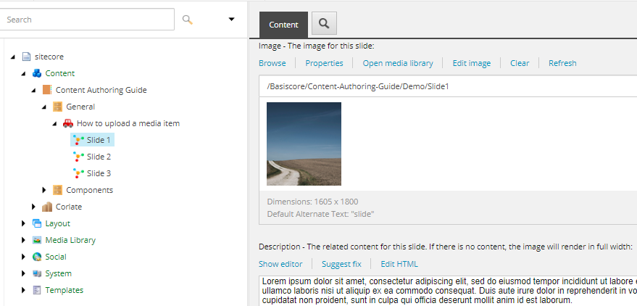4. Now, similarly create another **Article** for the Accordion.  
  
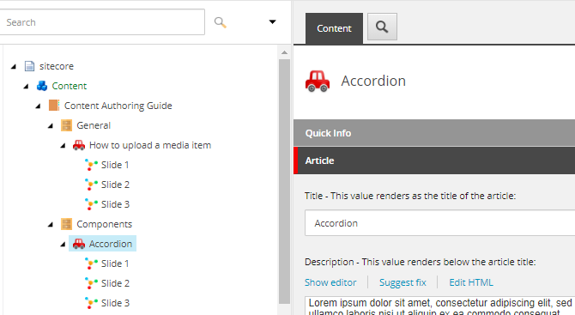

5. Browse the CAG page and you can see that the content and menu are rendered using the Sitecore items that you have just created.  
  
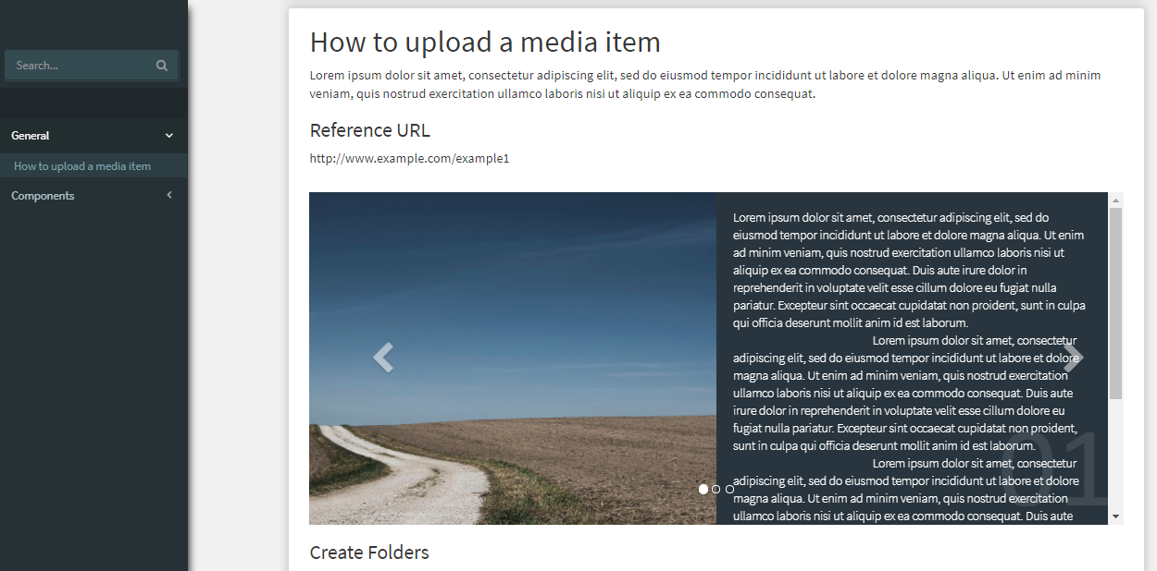  
  
  
Search  
  
Authors can also use the search feature on the page to search for articles having the keyword.  
  
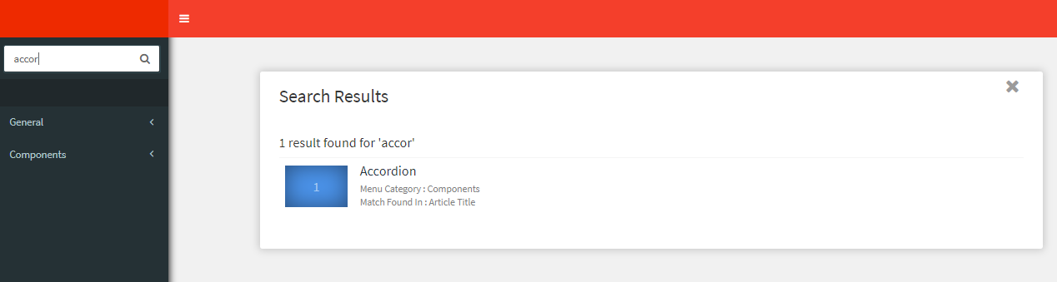

The keyword should have minimum 2 letters.

The application will search for the keyword in the following fields and display the results:

*Article* - Title, Description, Reference URL, Section header & description fields.  
*Carousel Slide* - Description.

# How to Have Multiple Guides

1. If you have multiple sites in your instance, you can create another **Content Authoring Guide** item for that site using the branch template - */sitecore/templates/Branches/Basiscore/Content Authoring Guide/Guide Root*2. To have its Launch Pad icon, create a new item in the core database under */sitecore/client/Applications/Launchpad/PageSettings/Buttons*. The template should be */sitecore/client/Applications/Launchpad/PageSettings/Templates/LaunchPad-Button*.  
3. In its **Link** field, give the URL as */ContentAuthoringGuide/<id of your new Guide Root item>*